TO LET RETAIL/INDUSTRIAL UNIT

3 Hawker Drive
Martlesham Heath Business Park, Ipswich, Suffolk, IP5 3RQ

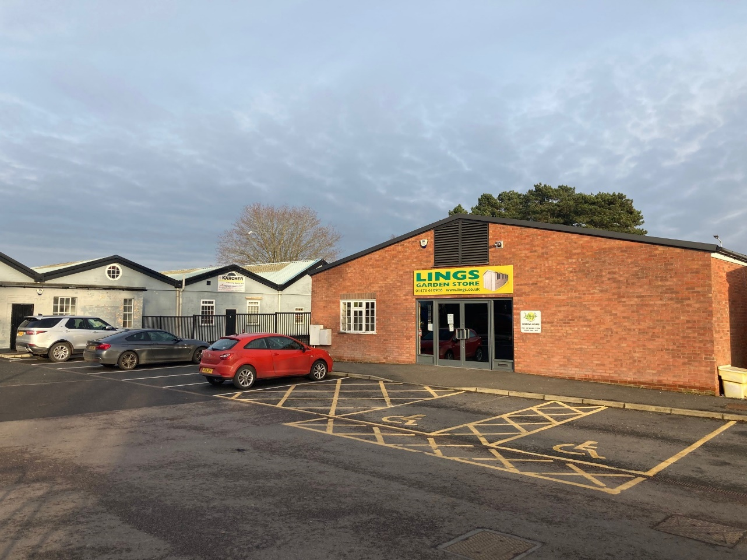

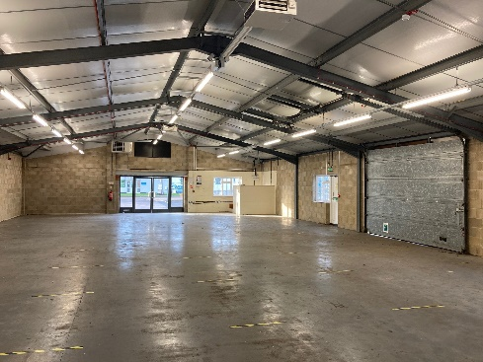
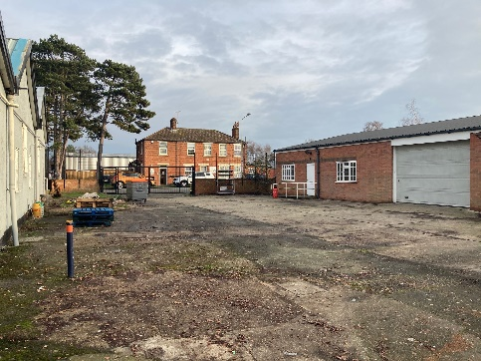

Units 9 & 10

01473 234836

savills.co.uk

Location

Ipswich is the county town of Suffolk with a population of approximately 130,000 and a catchment area of over 250,000. It occupies a strategic position close to the International Container Port of Felixstowe and the interchange of the A12 and A14 trunk roads. The town is also served by a rail service to London Liverpool Street with a journey time of approximately 75 minutes.

Martlesham Heath Business Park is located adjacent to the A12 dual carriageway in close proximity to Junction 28 of the A14. The estate, together with the adjoining retail park, comprises of a variety of occupiers including DHL, Ladbrokes, Howdens, Orwell Trucks, Tesco, Jewson.

Description

Steel portal frame retail/industrial unit with block/brickwork elevations with profile steel cladding to the upper parts with pedestrian access to a communal car park fronting Gloster Road and vehicle access from Hawker Drive. The property comprises a portal frame building with an open plan retail/storage area with cellular offices, male/female toilet facilities and kitchenette to one end. To the side elevation is an up and over loading door. Externally there is a gated and fenced yard to the side of the property with vehicular access to Hawker Drive

Consideration will be given to splitting the unit into two units, comprising a retail unit fronting Gloster Road of 1,200 ft² and an industrial/trade counter unit to the rear of 2,400 ft² accessed from Hawker Drive.

Accommodation

The premises provide the following approximate floor areas:

Ground Floor: 3,610ft² (335.40m²)

Areas provided are on a Gross Internal Area (GIA) basis.

Eaves Height: 2.66m to the underside of the roof

Terms

The premises are available on a new FRI lease for a term of 5+ years at a rental to be agreed by negotiation.

Services

Mains drainage, water, gas and electricity are believed to be available to the property. Interested parties are however advised to make their own enquiries of the relevant service providers.

Buildings Insurance

The tenant is to reimburse the landlord the cost of buildings insurance premium.

Business Rates

From indirect enquiries made of the Valuation Office Agency (www.voa.gov.uk) website we understand that the premises have a Rateable Value of £18,000 (2017 Valuation).

For the year Commencing 1st April 2020 rates are normally charged at 51.2 pence in the Pound on the Rateable Value. However the amount payable may be affect by Small Business Rates Relief or transitional adjustment and could be higher or lower. Interested parties are advised to check with the Local Rating Authority.

Service Charge

A service charge will be levied in respect of a contribution towards the upkeep of common areas and estate management. For the Budget Year, 1st January – 31st December 2020 the Service Charge is estimated at £1,342.16.

Planning

Interested parties should satisfy themselves as to the suitability of the current planning consent for their proposed use of the premises by contacting the Local Planning Authority.

EPC

TBC

Important

The services, fixtures, fittings, appliances and other items of equipment referred to have not been tested by this firm and therefore no warranty can be given in respect of their condition. Interested parties should satisfy themselves as to their condition.

Legal Costs

Each party to bear their own legal costs.

Viewing and further information

Strictly by prior appointment with the Joint Sole Letting Agent

Savills
Phil Dennis
Tel: 01473 234836
Email: pdennis@savills.com

Or

Elsom Spettigue Associates
Peter Elsom
Tel: 01394 446480
Email: peter.jo.elsom@eaassociates.co.uk

IMPORTANT NOTICE

Maps are reproduced from the Ordnance Survey Map with the permission of the Controller of H.M. Stationery Office. © Crown copyright licence number 100022432 Savills (UK) Ltd, published for the purposes of identification only and although believed to be correct accuracy is not guaranteed. Savills, their clients and any joint agents give notice that: 1. They are not authorised to make or give any representations or warranties in relation to the property either here or elsewhere, either on their own behalf or on behalf of their client or otherwise. They assume no responsibility for any statement that may be made in these particulars. These particulars do not form part of any offer or contract and must not be relied upon as statements or representations of fact. 2. Any areas, measurements or distances are approximate. The text, photographs and plans are for guidance only and are not necessarily comprehensive. It should not be assumed that the property has all necessary planning, building regulation or other consents and Savills have not tested any services, equipment or facilities. Purchasers must satisfy themselves by inspection or otherwise.
21st January 2021

