|  |
| --- |
|  |

**Summary**

* Semi-detached single-storey industrial/warehouse unit with a mezzanine area
* Type: Industrial/Logistics
* Tenure: For Sale with income
* Size: 1,890 sq ft Gross Internal Area
* Price: Offers in excess of £300,000 exclusive

**For Sale**

**Industrial/Logistics - 1,890 sq ft Gross Internal Area**

Unit 1, Old Station Approach, Leatherhead, Surrey, KT22 7TE

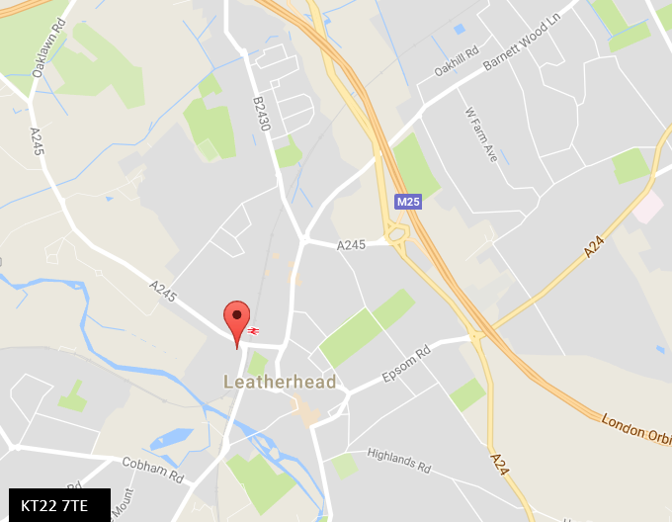

# Energy Performance Rating

The property has been graded as 106 (E).

# Rent

Offers in excess of £300,000 exclusive.

**Business Rates**

Available on request.

**Service Charge**

Available on request.

# Viewing and Further Information

If you are interested and would like more information please get in touch.

**Contact**

Tim Clement

**t. +44 (0)20 7087 5303**

**e. Tim.clement@eu.jll.com**

Jamie Prys-Owen

**t. +443 (0)20 7852 4240**

**e. jamie.prys-owen@eu.jll.com**

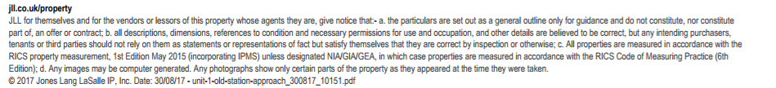

**Location**

Leatherhead is located approximately 18 miles south-west of Central London with good access to the national motorway network via Junction 9 of the M25. The property is situated on Old Station Approach which is approximately 3 minutes’ walk from Leatherhead mainline station which provides frequent services to London Victoria and London Waterloo with an approximate travel time of 40 and 34 minutes respectively.

The Town Centre is a short walk from the property and provides a good level of amenities.

**Description**

Unit 1 is a semi-detached single-storey industrial/warehouse unit with a mezzanine area. The property is accessed via two pedestrian doors leading directly to the staircase up to the mezzanine floor and the office area. In front of the property is a brick paviour roadway including approximately 8 car parking spaces.

**Accommodation**

We have measured the unit in accordance with the RICS Code of Measuring Practice (6th Edition) and calculated the approximate gross internal areas as follows:-

|  |  |  |
| --- | --- | --- |
|  | **Sq ft** | **Sq m** |
| Ground Floor | 1,410 | 130.99 |
| Mezzanine | 489 | 44.59 |
| **Total GIA** | **1,890** | **175.28** |

**Tenure**

The property is held on a long leasehold interest for a term of 150 years from 25th September 1987 and sub-let to Trevor Sorbie International on a 5 year lease term granted outside the Security of Tenure Provisions of the Landlord and Tenant Act 1954 (Part II) from 22nd March 2015 and the current passing rent is £22,000 per annum.

**VAT**

VAT will apply to the purchase price / rent, if applicable.