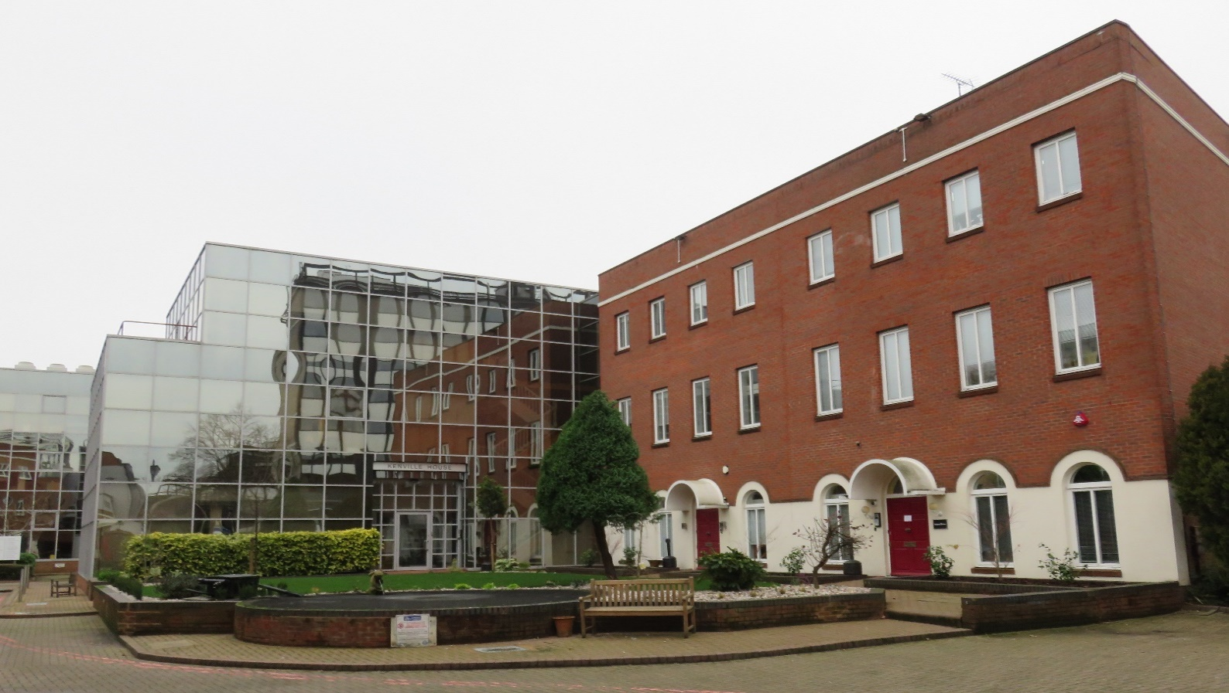

**OFFICE TO LET**

**Axiom House, Spring Villa Park, Edgware, HA8 7EB**

1440 SQ FT (132 SQ M.)

**Location:** Spring Villa Park is a prestigious and well maintained office campus situated on High Street (A5), Edgware with a manned gated entrance and 24-hour access. Conveniently situated a few minutes’ walk from Station Road which affords access to multiple shopping facilities, banks and Edgware underground station (Northern line) and Bus station. The M1 M25 and A1 are all within easy reach.

**Description:** Entire first and second floor benefiting from air conditioning, central heating and excellent natural light. The suites includes 5/7 parking spaces with the option of an additional 6 spaces by separate negotiation.

|  |  |
| --- | --- |
| Commissionaire  Air conditioning  Good Natural Light  Central Heating | Male & Female WC’s  Parking  Carpet Tiled Flooring  Kitchenette |

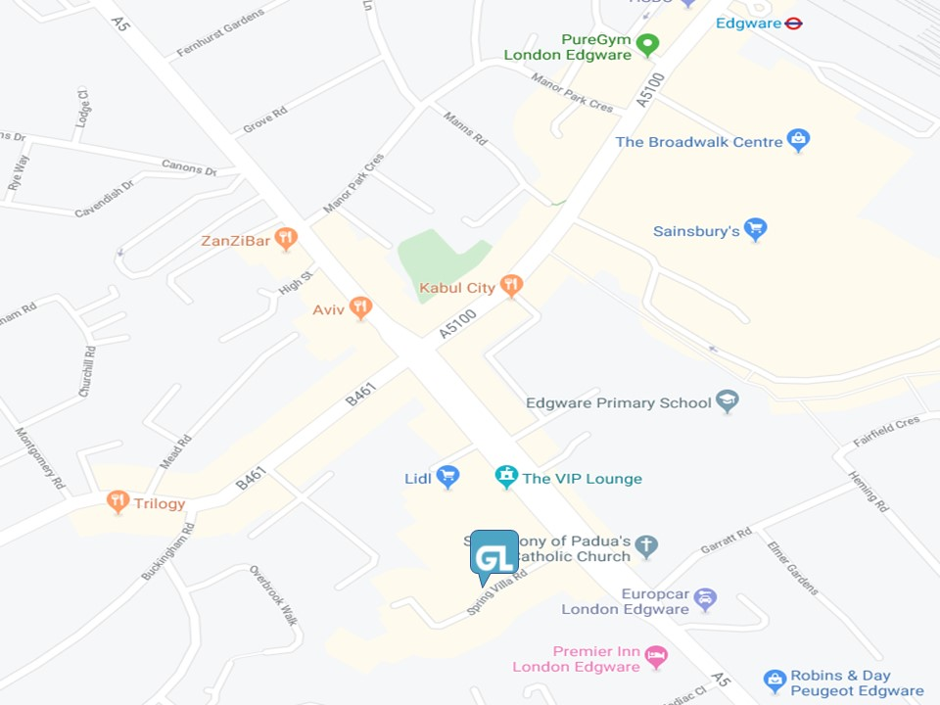

**Tenure:** Leasehold.

**Terms:** A new FRI Lease available direct from the Landlord.

**Rental:** £60,000 inclusive of service charge, business rates and utilities. V.A.T is not applicable on the rent.

**EPC:** Energy Performance Certificate Rating ‘C’.

**Referencing:** A charge of £100 + VAT is payable for taking up references on behalf of proposed tenants. This fee is non-refundable after the references have been taken up, whether or not they have been accepted by the landlord.

**LEGAL COSTS:** Each party to be responsible for their own legal costs.

|  |  |
| --- | --- |
| **Danny Pincus** | **Aharon Goldstein** |
| Tel. 020 8952 6434 | Tel. 020 8952 6434 |
| [danny@goldsteinleigh.com](mailto:danny@goldsteinleigh.com) | [aharon@goldsteinleigh.com](mailto:aharon@goldsteinleigh.com) |
|  |  |

**Viewing & further information**

Strictly by prior appointment

**MISREPRESENTATION ACT 1967** Messrs. Goldstein Leigh for themselves and for the vendors or lessors of this property whose agents they are given notice that: I) the particulars are set out as a general outline only for the guidance of intending purchasers or lessees, and do not constitute, nor constitute part of, an offer or contracts; II) all descriptions, dimensions, references to the condition and necessary permission for use and occupation, and other details are given in good faith and are believed to be correct, but any intending purchaser(s) or tenant(s) should not rely upon them as statements or representations of fact and must satisfy themselves by inspection or otherwise as to the correctness of each of them; III) no person in the employment of Goldstein Leigh has any authority to make or give any representation of warranty in relation to this property; III) all rentals and prices are quoted exclusive of VAT.